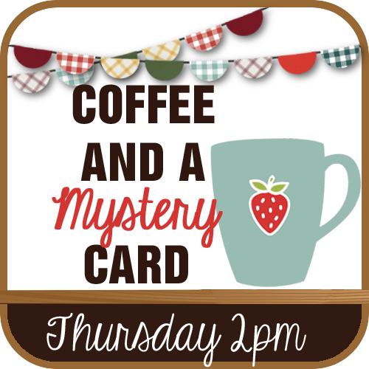
CLUES #1 – GATHER YOUR SUPPLIES

- Solid color cardstock, 8-1/2 x 5-1/2”, scored at 4-1/4”
- Solid color cardstock, die cut shape layer – your choice of share, at least 3” wide
- Whisper White Cardstock for your sentiment
- Designer series paper, die cut shape layer to nest with solid color die cut shape
- Small die cut solid color cardstock pieces
- Ink pads to coordinate with your designer series paper
- A stamp image/s that can be die cut, punched or fussy cut
- Solid color cardstock scraps to stamp your image on
- A background stamp/s
- A sentiment stamp
- Ribbon, twine, lace or trim of your choice and embellishments

